Relationships Matter

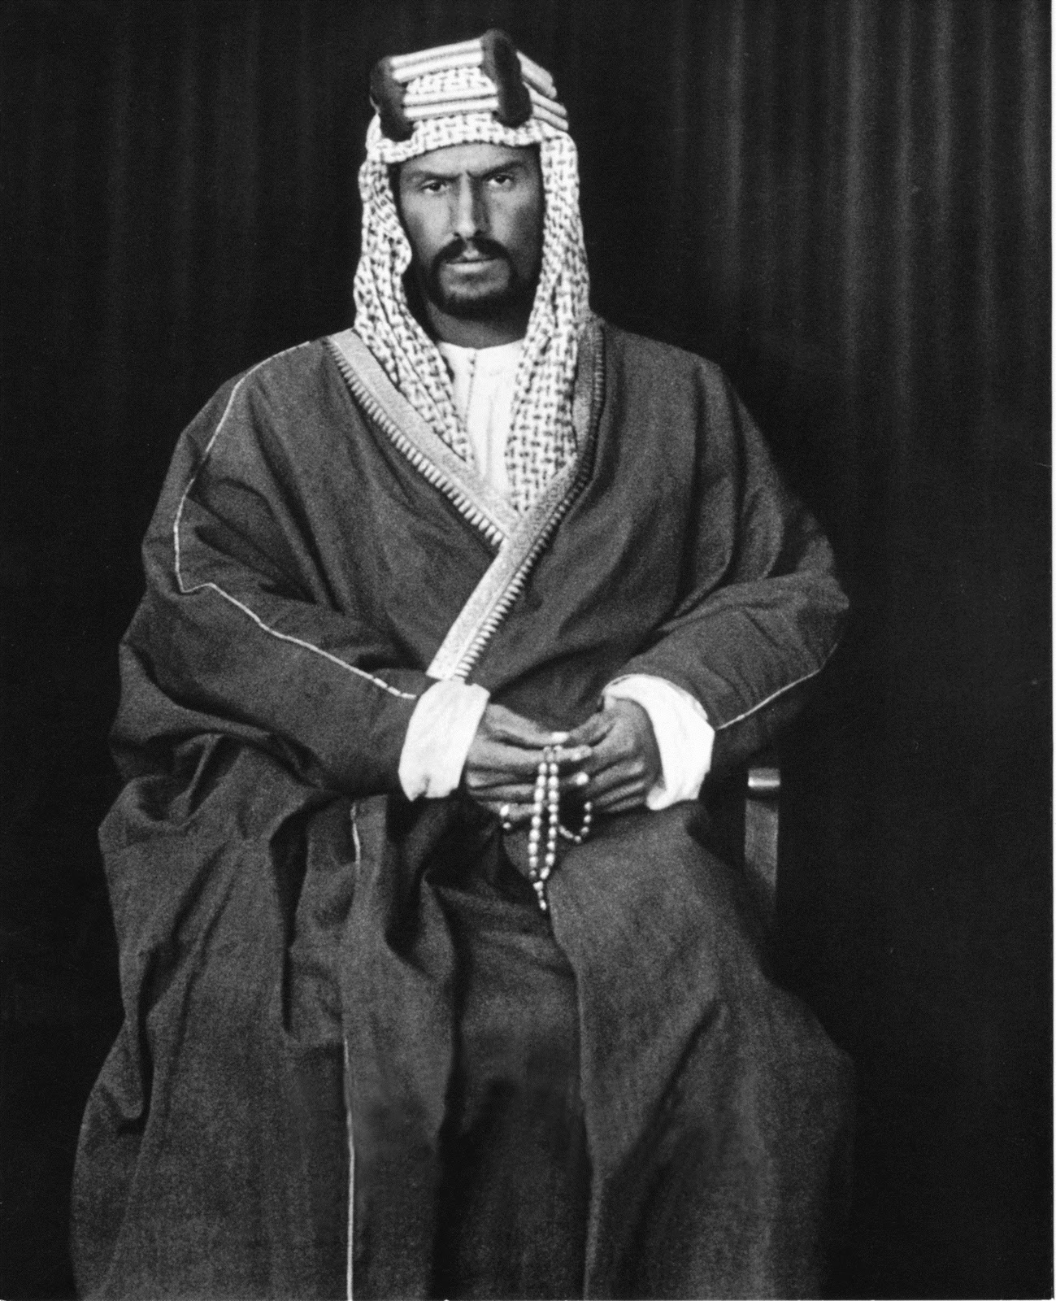

Ibn Saud United Arabian Peninsula His country was named Saudi Arabia He was a warrior who had created the modern Saudi kingdom through endless battles.

The king of saudi Arabia, who signed himself ‘Abdul Aziz AI Saud” but who has come to be known as “Ibn Saud,” was one of the great men of the twentieth century. He won his kingdom and united his people by his personal leadership. He possessed those epic qualities of the leader which Samuel recognized in Saul;* he excelled in the common tasks which all must perform. He was taller, his shoulders were broader, he was a better hunter, a braver warrior, more skillful in wielding a knife whether in personal combat or in skinning a sheep, he excelled in following the tracks of camels and finding his way in the desert. In him his subjects saw their own lives in heroic size, and therefore they made him their king.
FDR Meets Ibn Saud

“In 1938, the subsidiary of a US company, Standard Oil of California, had bought drilling concessions in the Arab peninsula, and prospects looked promising. The subsidiary was called California Arabian Standard Oil Company and would become the foundation of what is now the world's most valuable company: Saudi Aramco.”

In 2022, the US spent over $70 billion in foreign aid to nearly 200 countries, territories, and geographic regions — around 1% of the federal budget. USA Facts

“Resentful of the British who prevented further expansion of his realm into Transjordan and southern Iraq and inherently distrustful of the French, he would turn to the nation whose citizens had worked so selflessly for his people’s welfare. (Oren Page 409)

If I want to trade with you our gods are cousins. It I want to overtake you my god is superior to your god.

CNN World

Trust is the most important ingredient/determinate in relationships. The United States has spent over six decades building relationships with people all over the world. Americans have worked and lived in remote areas of the world supplying humanitarian assistance and building relationships. The top countries receiving aid in 2023 were Ukraine, Israel, Jordan, Egypt, Ethiopia, Somalia, Nigeria, and Congo. U.S. News

Trust

Trust

We import essential medicines, critical minerals

It is cruel and short sited to abruptly stop aid to these countries. The U.S. is sending a message to the rest of the world that we are more concerned about expedience for ourselves than fulfilling the missions we committed to. Shortly after WWII President Franklin Roosevelt negotiated with the leader of Saudia Arabia.

Ukraine exports sunflower oil. Ukraine is often called the “breadbasket of Europe” because of its ideal conditions for growing wheat. World Vision

China and Russia may benefit NBC News

As the Trump Administration has pursued its goal of reducing government spending, it seems to be taking the same approach as big cats do when pursuing prey: move fast and take down the most vulnerable first. And the results are just as brutal. The U.S. was the biggest distributor of funds to countries in crisis, providing more than 40% of the world's nonmilitary foreign aid. When that wallet is suddenly zipped, even for three months, it puts the aid network under so much pressure that small holes in the web of support grow into chasms. Time

“After the U.S. military pulled out of Afghanistan, humanitarian agencies spent months negotiating with Afghan leaders to allow girls to go to school beyond third grade in some regions. Aid agencies there worry that even if funds for the schools are restored after 90 days, the hard-won memoranda of understanding signed by the authorities may need to be renegotiated. "We have lost precious time in which girls can access schools, we may be losing negotiating power with the de facto authorities, and we may lose core design elements that are critical," says one agency director.” Time

Agriculture is another area where the halt has squandered effort and time. World Relief, one of the few agencies funded by USAID to speak up about the impact of the funding cut, says it has 3.9 metric tons of bean seeds in Haiti that it cannot distribute, because of the stop-work order. "If they are not distributed soon, then the seeds will rot, farmers will miss planting season, and families will be at high risk for food insecurity," the organization said in a statement to TIME. "These are real people, real lives, hanging in the balance. This isn't about politics; it's about the very real consequences of these funding delays on the people we serve." Time

Food, medicine, healthcare, education, clean water, agriculture, international development, clinical trials, stopped abruptly in many parts of the world. The abrupt stop order displayed a cruel disregard for human relationships and human suffering even human lives. “The Global Health Bureau, currently staffed at 147 people, and whose strategic priorities are to prevent child and maternal deaths, control the HIV/AIDS epidemic and prevent the spread of infectious diseases, will be reduced to 77 people.” NPR “Popular programs that manage emergency response and promote global health have been incapacitated.” Foreign Affairs

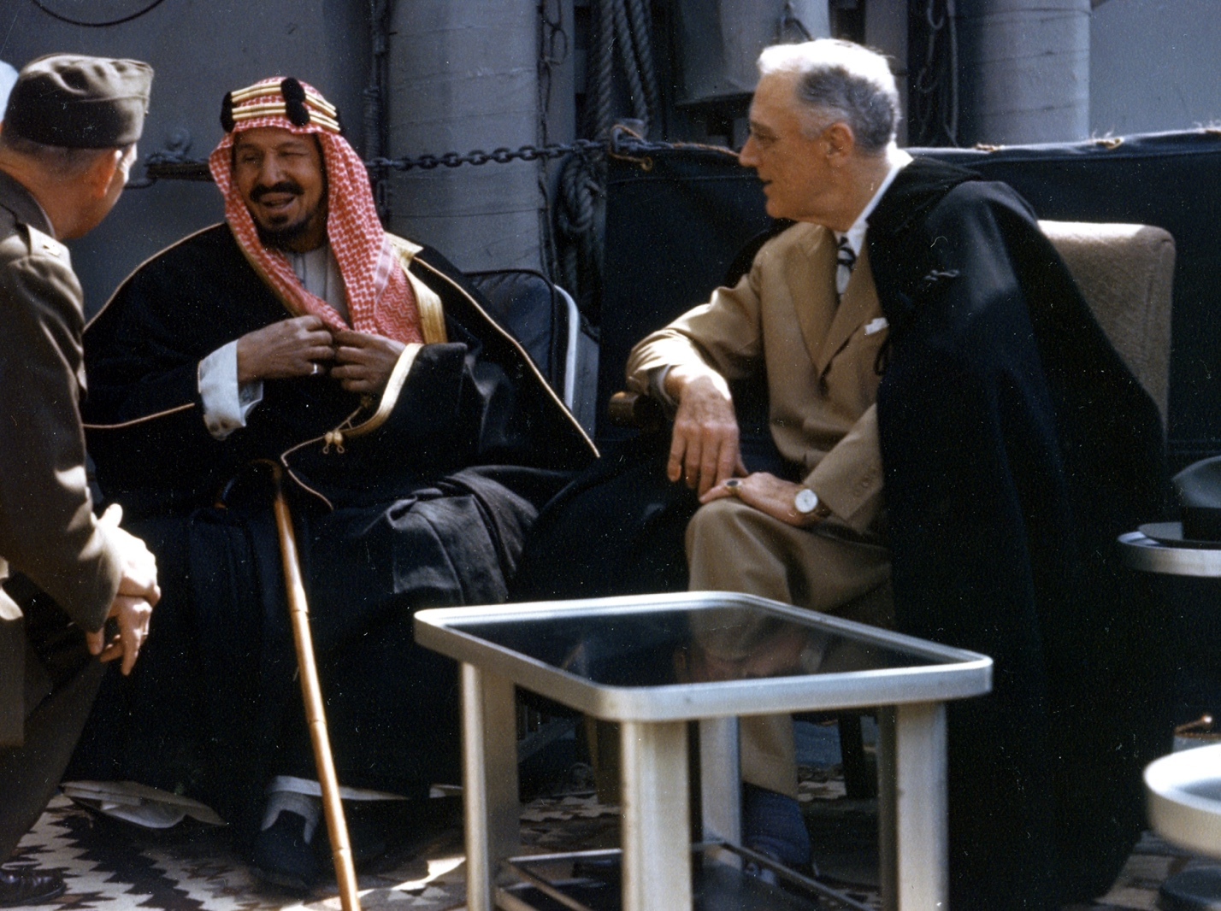

Abdulaziz (left) and Roosevelt aboard USS Quincy during their historic 1945 meeting
Wikipedia Valentine’s Day 1945
You Tube 2 Minutes

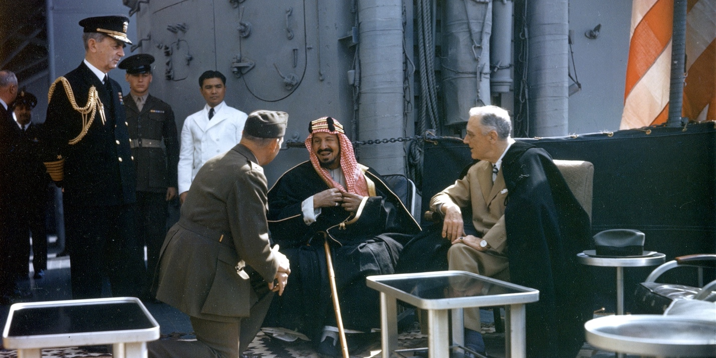
National Archives Getty Images
https://archive.org/details/FDRMEETSIBNSAUD
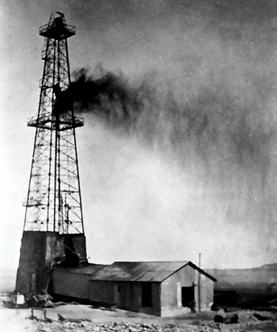

Dammam No. 7, the oil well where commercial volumes of oil were first discovered in Saudi Arabia on March 4, 1938. Wikipedia

“Saudi Arabia is presumably the only country in the world whose development of oil and mining resulted from purely philanthropic sentiment.” (Twitchell Oren Page 417)

